MN50754 ANALYTICS IN PRACTICE
Amsterdam Accommodations: Accessible and Affordable
Insights for Low-Income Travelers with Infants
by Ritwik Singh
MSc Business Analytics
School of management
University of Bath


Word Count: 1976

Contents

1. Executive Summary 3
2. Introduction 3
3. Empathy Map 3
4. Data Analysis 4
a. Main Tourist Attractions Around the City 4
b. Data Gathering 5
c. Data Preprocessing 5
d. Data Quality 5
e. Understanding the Price Distribution 6
f. Understanding the Property Type Distribution 7
g. Neighbourhood Listings and Location Ratings 8
h. Exploring Neighbourhoods based on Price 8
i. Exploring Various Accommodation Options 9
5. Conclusion of the Report 10
6. References 12
7. Appendix 12

Executive Summary
The report identifies several opportunities to improve accommodation options for low-income family with infants in Amsterdam:
- The report recommends increasing the availability of budget-friendly Bed and Breakfast establishments to address current shortages in this sector within the range of $50 to $150.
- It suggests the development of low-cost apartments equipped with amenities suitable for infants, catering to the needs of families traveling on a budget.
- Additionally, the report proposes exploring the concept of low-budget houseboats situated away from the city centre to offer unique lodging experiences.
- It suggests considering the repurposing of unused canal boats into affordable accommodations, providing a sustainable and distinctive lodging choice for visitors seeking budget-friendly options in Amsterdam within the range of $50 to $150.
- Remove minimum night requirements for private rooms to increase options for one-night stays.

Introduction
Amsterdam, often hailed as the "Venice of the North," stands as the bustling capital and key financial hub of the Netherlands. Renowned for its picturesque canals, rich history, and world-class museums, Amsterdam holds a prominent position among Europe's top travel destinations. Beyond its allure for leisure travellers, the city also beckons a steady stream of business visitors from around the globe (cycles and Text, 2023).
With a small population, Amsterdam currently boasts ~17 million residents as of February 2024 (opendata.cbs.nl, n.d.). Despite its significant local population, Amsterdam graciously accommodates a remarkable influx of tourists, welcoming over 16.1 million visitors in 2022 (Statista, n.d.). This surge in tourism underscores Amsterdam's enduring charm and status as a premier travel destination.
However, meeting the diverse accommodation needs of Amsterdam's visitors poses a significant challenge, particularly due to the city's limited hotel capacity. With a relatively smaller number of hotels compared to the growing demand, securing suitable lodging can be a difficult task for travellers which can also prove to be heavy on the pocket.
To address this challenge, a huge number of online listings like Airbnb, Booking.com, etc., offers travellers a wide array of options, ranging from cozy apartments to picturesque canal-side houseboats, catering to various preferences and budgets.
Overall, the combined direct and indirect contributions of these industries to the country's GDP amounted to approximately €88.6 billion in 2022 (Statista, n.d.).
This report delves deeply into exploring budget-friendly options tailored to the needs of low-income households with infants, aiming to provide actionable insights for enhancing accessibility and affordability in Amsterdam's hospitality sector.

Empathy Map:
Through design thinking techniques, insights were gathered to produce a thorough picture of the perspectives of low-income families with infants.
What They Say: Low-income couples with young children prefer cosy and reasonably priced accommodation options in Amsterdam. There is a need of affordability when looking for accommodations that would suit their limited spending plans while still providing a warm and safe environment for their child. Some important features like cribs and childproofing are demanded.

What They Do: Convenience and accessibility are the top priorities for them. To make it easier to navigate the city with their infant, they typically choose lodgings that are centrally placed and near family-friendly attractions and public transportation. They also participate in family-friendly activities, like going to parks, museums, and other kid-friendly establishments.
What They Think and Feel: When travelling in Amsterdam, they choose security and peace of mind so they can unwind and take in their surroundings worry-free. Since they want accommodations that provide a true taste of Amsterdam culture and way of life, authenticity and local charm are also crucial factors.
Pain Points: Managing practical concerns like childcare and transportation, as well as navigating Amsterdam's busy streets, present challenges for them. In addition, they could become frustrated by the outrageous costs and restricted selection of lodging, especially during the busiest tourist seasons.
Gains: They appreciate personalized recommendations and insider tips for making the most of their time in Amsterdam, as well as additional amenities and services that enhance their travel experience and create lasting memories for their family.

Data Analysis
R-studio is used for the overall data exploration, preprocessing, and creating visualisations. The variables mentioned in the data preprocessing sections are renamed for a better understanding and detailed analysis.

Main Tourist Attractions Around the City

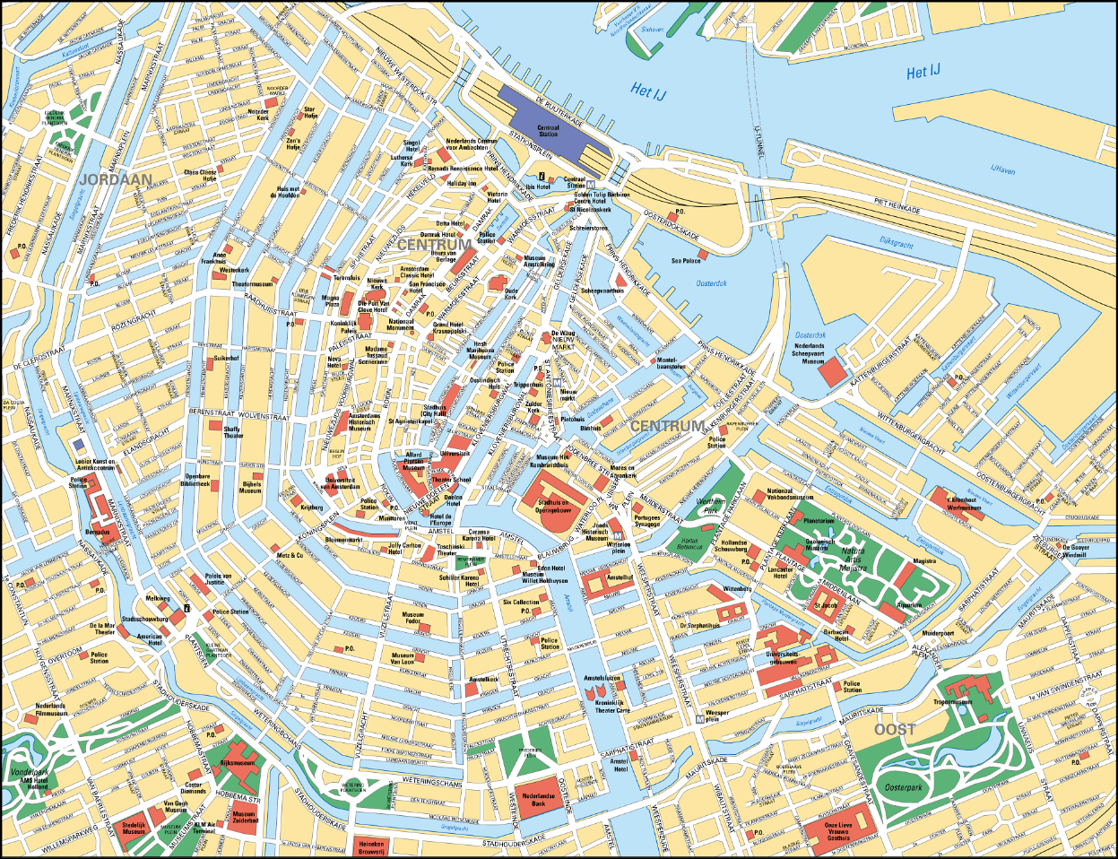
Fig 1. Tourist Attractions Map of Amsterdam

“Amsterdam Centrum” is the centre of the Amsterdam where all the main attractions are found as show in Fig 1. This area is split into two parts namely Centrum-West and Centrum-Oost, which is always buzzing with activities. There are various neighbourhoods surrounding the Centrum such as the Van Gogh Museum and the Rijksmuseum. The Anne Frank Museum has a great historical significance, and the night life of the city makes sure that there is never a dull moment after the sunset.

Data Gathering
The data file used for analysis, called "listings.csv.gz", was obtained from Inside Airbnb, a website that provides publicly Airbnb available data (Inside Airbnb, 2019).

Data Preprocessing
The data file in consideration consists of 8739 rows and 46 columns containing the data of listings in Amsterdam which will be needed for further analysis. A data frame is created with only the required variables for exploring the current listings and understanding the market gaps.
The following variables are explored for the analysis:
- Name
- Price
- Neighbourhood
- Review Score Rating
- Property Type
- Number of Reviews
- Location Score
- Room Type
- Value for Money
- Minimum Nights

Data Quality
The initial step to start data analysis is to do the data cleaning by converting the missing values to NA to drop the null values for the ease of analysis. For further analysis, a visualization of NA values is given below to understand the completeness of data as shown in Fig 2.
Most rows exhibit complete data without any missing values. Approximately 10% of values are missing in the "Location Score", "Value for Money", and "Review Score Rating" columns respectively. Given that 96.9% of the data is available, the analysis conducted on the dataset is performed with minimum loss of information.

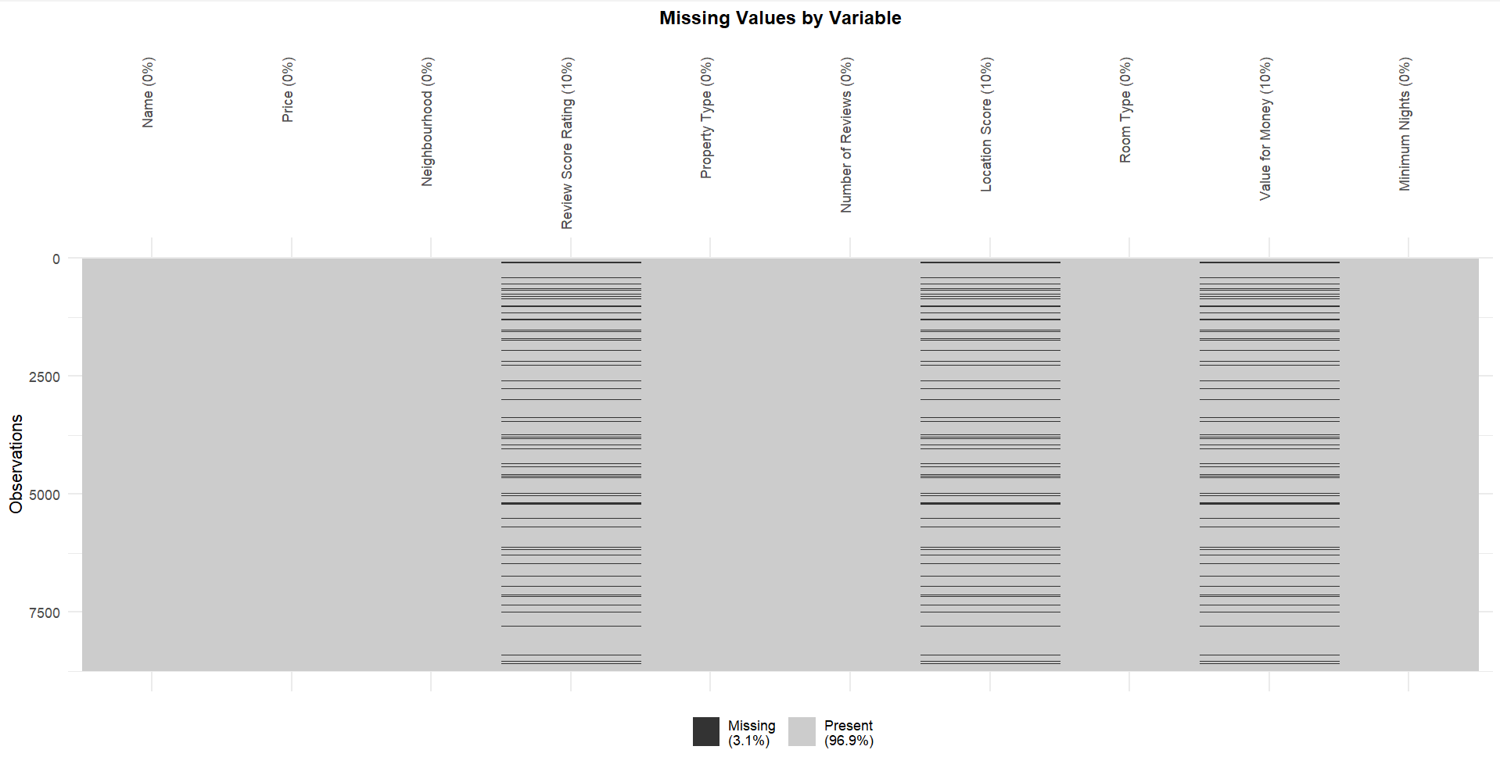
Fig 2. NA Values in the Dataset

Understanding the Price Distribution
The price distribution ranges from a minimum of $10 to a maximum of $25,457, with a mean of $251.16 and a median of $200. However, due to outliers, that are not relevant to the target demographic, in the data, the analysis focuses on prices between $0 and $526.50.

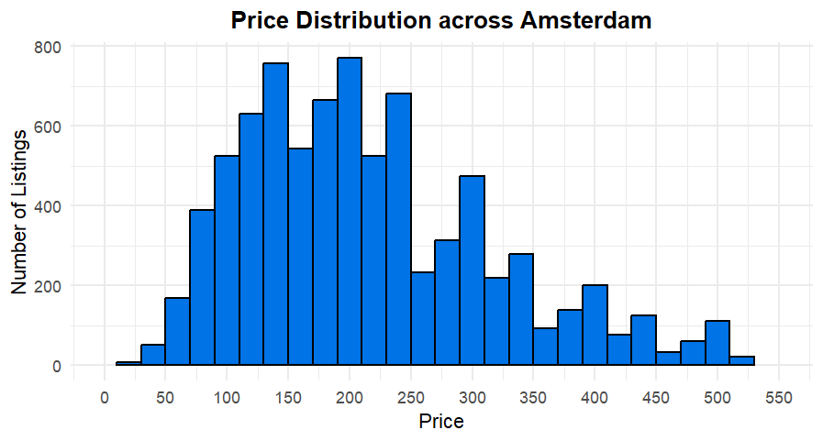
Fig 3. Accommodation Price Distribution across Amsterdam

Conclusion: The analysis indicates a right-skewed price distribution, with most listings falling between $100 and $250 per night. However, for lower-income categories, the ideal price range is $50 to $150 per night, aligning with their tendency to spend less on accommodation. Only 58 out of 8739 listings fall within the $0 to $50 range, comprising just 0.71% of total listings, highlighting an opportunity to introduce more affordable options.

Understanding the Property Type Distribution
There are a total of 62 distinct property types listed in the dataset. These types were categorized based on the following criteria:

Fig 4. Categorisation of Property Types

Below is the graphical representation showing the number of listings per property type across Amsterdam:
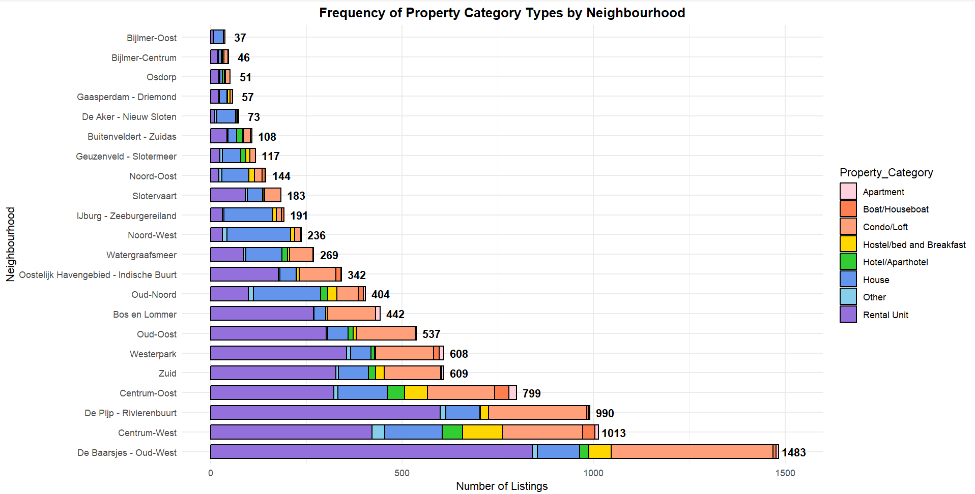
Fig 5. Number of Listings for Each Property Type by Neighbourhood

Fig 6. Number of Listings for each Property Category

Fig 6 indicates a notable market presence of Rental Units and Condo/Loft accommodations in Amsterdam, which may not suit low-income families. With 1,592 houses listed, there's significant availability, yet fewer than rental units. The scarcity of Apartments presents an opportunity to develop affordable options tailored to low-income couples with infants. This highlights a substantial market gap for smaller, budget-friendly accommodations.

Neighbourhood Listings and Location Ratings
The analysis in Fig 7 examines the distribution of Airbnb listings and average ratings across different neighbourhoods in Amsterdam. It highlights a concentration of listings in western and central districts like "De Baarsjes - Oud-West," "De Pijp - Rivierenbuurt," and "Centrum-West," indicating heightened demand likely influenced by proximity to tourist attractions and amenities. Conversely, neighbourhoods like "Bijlmer-Oost" show fewer listings, potentially due to their residential nature or stricter regulations. This graph is arranged in a way wherein the descending order of average ratings, with areas like "Centrum-West" receiving higher ratings, suggesting positive guest experiences, better amenities, and aid long term return on investment.

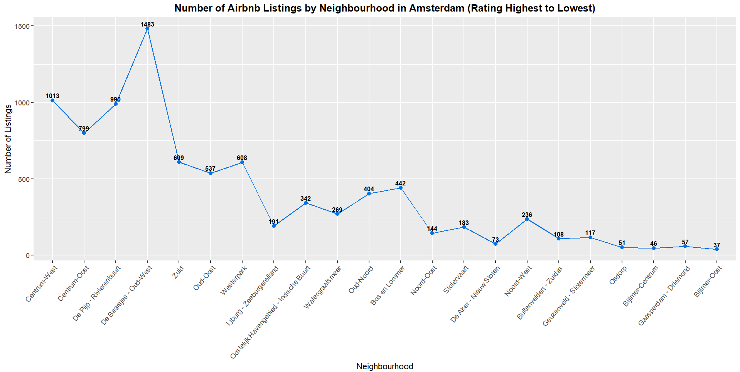
Fig 7. Number of Listings as per Location Ratings(Highest to Lowest)

Conclusion: Since they may have limited funds, they often prioritize accessibility to attractions and public transportation. Positive location ratings indicating proximity to key landmarks, affordable dining options, and safe neighbourhoods could make a budget-friendly accommodation more appealing.

Exploring Neighbourhoods based on Price
The analysis below provides insights into the distribution of average prices for accommodation across different neighbourhoods in Amsterdam. It identifies "Buitenveldert - Zuidas" as the most expensive neighbourhood, due to some outliers indicating that it may offer premium amenities or have high demand, leading to elevated prices.

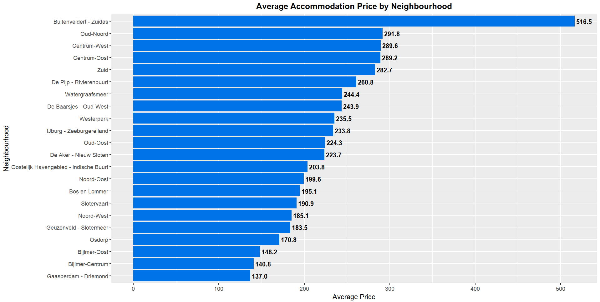
Fig 8. Average Price per Night by Neighbourhood

Conclusion: According to Fig 8, it is evident that there is a significant disparity in accommodation costs that are influenced by various factors such as location desirability, local amenities, housing quality, and socio-economic status of the areas.

Exploring Various Accommodation Options
- Exploring Boat/Houseboats
Houseboats offer a unique accommodation experience in Amsterdam, as seen in Fig 9. While shared rooms are pricier due to limited availability, private rooms offer affordability and privacy. With only 0.017% of listings, there's a clear opportunity to introduce more budget-friendly houseboats to attract more tourists.
Conclusion: Offering less expensive options outside of the city centre may also be beneficial. The main market gap is the lack of variety and affordability within the boat and houseboat categories in web listings for accommodations.
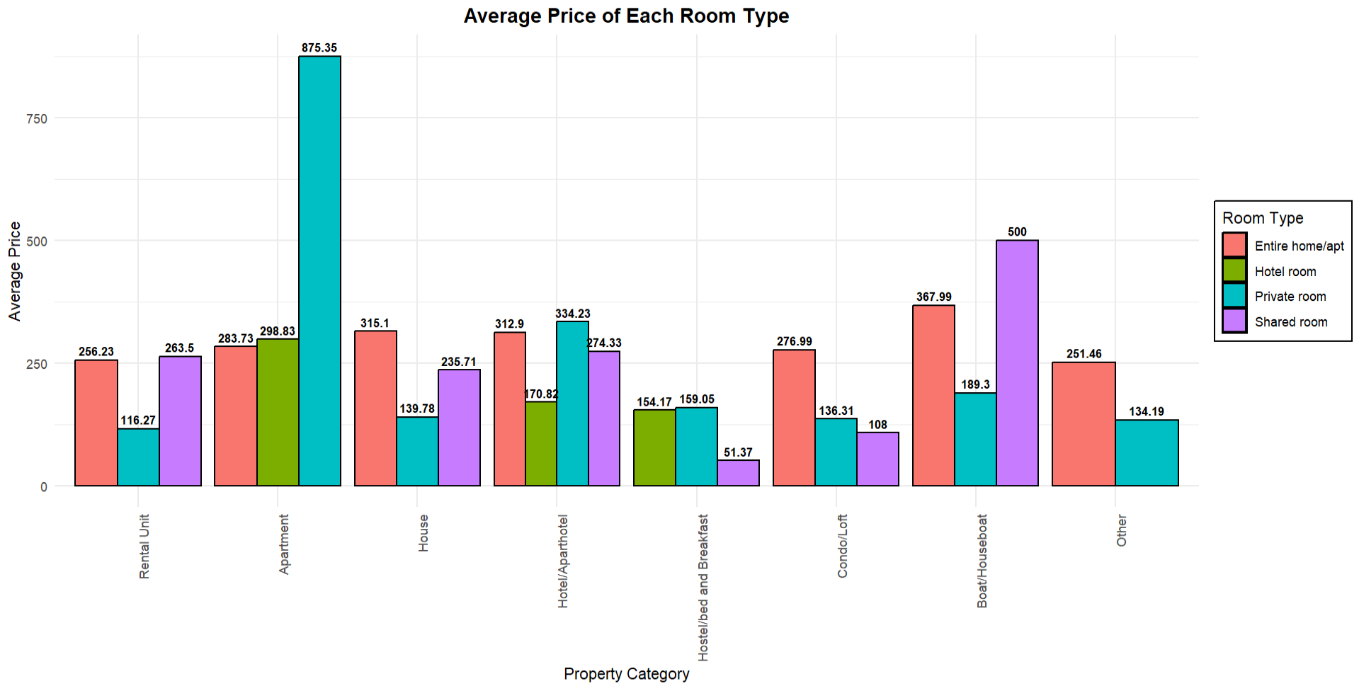
Fig 9. Exploring Various Property Types based on Average Price of each Room Type
- Exploring Hostel/Bed and Breakfast
From the analysis shown in Fig 10, the relatively high number of private room listings i.e. 323 indicates that there is a good supply of these rooms, potentially allowing for competitive pricing and the possibility of discounts for longer stays. For low-income families, the best option would likely be shared rooms due to their affordability, followed by hotel rooms if privacy is a priority. Bed and breakfasts and hostels are clearly positioning themselves to be accessible to travellers on a budget, with a variety of room types that cater to different family sizes and preferences.
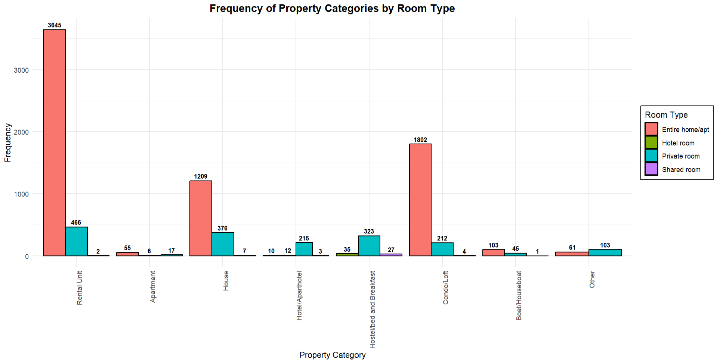
Fig 10. Exploring Various Property Types based on Frequency of each Room Type

Conclusion: Being one of the most feasible options for the low-income families, Bed and Breakfast just has 0.03% of listings in the dataset. The introduction of new Bed and Breakfast with private rooms would be a great opportunity to fill the market gap.

- Exploring Independent Apartments
Out of listings dataset, only 0.008% suggest that there are apartments listed as Independent Apartments. This suggests that there is a high need of independent apartments. As the analysis is done based on property category, the entire Apartment presents the most cost-effective and practical choice, offering both space and privacy at a reasonable price. The scarcity and higher cost of hotel rooms and private rooms within apartments make them less attractive for budget-conscious travellers. Therefore, entire homes/apartments would be the recommended option for families looking to maximize value for money.
Conclusion: This statement suggests the limited availability of one-night accommodations, particularly in private rooms, due to minimum night requirements in current listings as a major market gap.

Conclusion of the Report:
In conclusion, the report highlights a significant market gap for budget-friendly accommodations in Amsterdam, especially for low-income families with infants. The data analysis and empathy mapping underscore the need for more affordable options, such as budget Bed and Breakfasts, infant-friendly apartments, and houseboats away from the city centre. Addressing these gaps will not only enhance accessibility but also improve the overall travel experience for visitors.
Limitations:
The report's limitations consist of issues with data cleanliness and missing values, as well as the potential influence of external factors like the COVID-19 pandemic on the dataset's accuracy and relevance.
Future Research could involve exploring the impact of regulatory changes on budget-friendly accommodations, delve into consumer preferences among low-income travellers, analyse broader economic factors affecting affordability, and investigate the role of emerging technologies like blockchain and artificial intelligence in enhancing accessibility and sustainability within the lodging sector. Furthermore, research into sustainable tourism practices and their integration within budget-friendly accommodations is crucial. Comparative analyses with other cities or regions can offer valuable insights into best practices and areas for improvement. Understanding the impact of evolving tourism trends, such as sustainable travel and experiential tourism, is also essential for adapting to changing consumer preferences and market dynamics. Overall, these research directions hold the potential to foster a more inclusive, accessible, and affordable lodging sector in Amsterdam.

References:
I. Topic: Tourism in Amsterdam [Online]. Statista. Available from: https://www.statista.com/topics/6025/tourism-in-amsterdam/#topicOverview.

II. insideairbnb.com, n.d. Get the Data [Online]. Available from: http://insideairbnb.com/get-the-data.html.

III. opendata.cbs.nl, n.d. CBS Statline [Online]. Available from: https://opendata.cbs.nl/#/CBS/nl/dataset/37230ned/table.

IV. Statista, n.d. Netherlands: number of inbound tourists 2014-2020 [Online]. Statista. Available from: https://www.statista.com/statistics/658819/inbound-tourism-forecast-in-the-netherlands/.

V. Statista, n.d. Travel & tourism total GDP contribution Netherlands 2019 [Online]. Available from: https://www.statista.com/statistics/810736/travel-tourism-total-gdp-contribution-netherlands/.

Appendix

This map depicts the proximity of different neighborhoods to Amsterdam Centrum (marked in black), alongside major tourist attractions denoted in purple, such as the Anne Frank House and Heineken Experience. The plot provides insights into distance from the city centre, with red plots indicating the nearest and green plots representing the farthest locations, while orange marks distant points. Utilizing Google MyMaps and showcased on Google Earth, this visualization offers an immersive perspective.

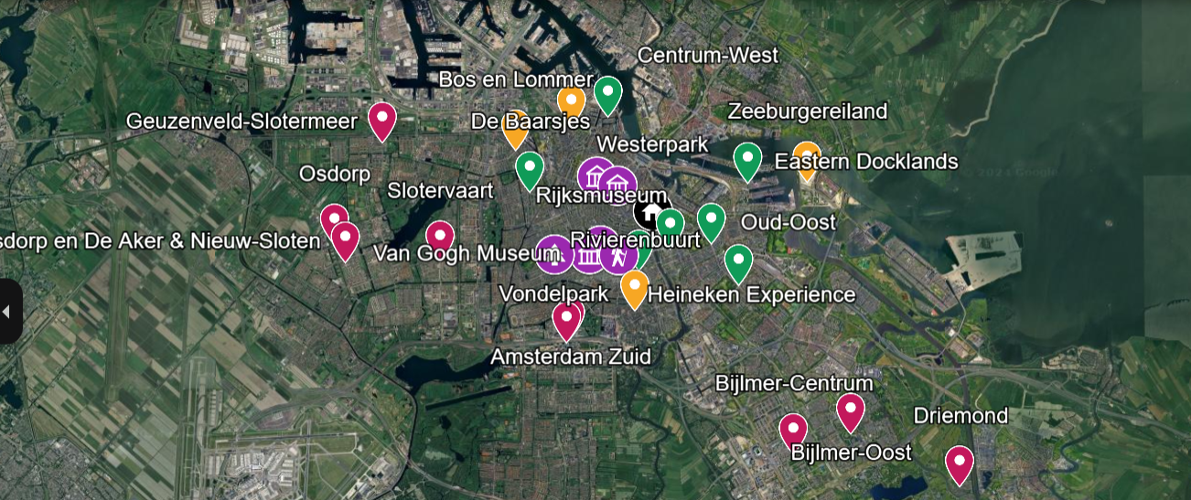
Fig 10. Map View of Proximity of Neighbourhoods from the Centrum

